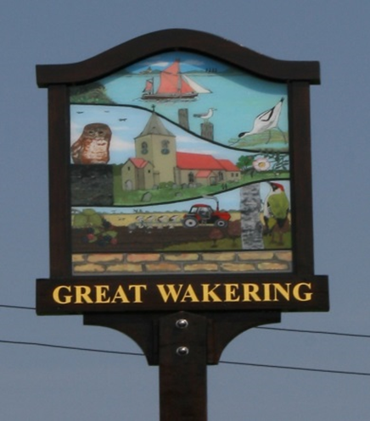
GREAT WAKERING PARISH COUNCIL
Villager of the Year 2026
ENTRY FORM
Proposer’s name…………………………………………………………………………………..
Address:……………………….…………………………………………..…………………………….
……………..…………………………………………………………………………………………………
Telephone number: ………………………………………………………………………………..
Email: ……………………………………………………………………………………………………..
Proposer’s signature:………………………………………………………………………………
Name of person being nominated:…………………………………………………………..
Address of nominee:………………………………………………………………………………….
Please explain why you are nominating this person on a separate piece of paper (150 words maximum).
Submit your entry by Noon 23 March 2026
By signing this form you agree to be bound by the terms and conditions of entry.
Preferably please return this form via email to:enquiries@greatwakering-pc.gov.uk by noon on the 23rd March 2026.
TERMS AND CONDITIONS OF ENTRY
This competition is free and the proposer and nominee must both live within the Parish of Great Wakering, other entries will not be judged.
To enter the competition you must complete, sign and return the nomination form by email or to the Parish Council Office by noon of the 23rd of March 2026. Entries received after this date will not be judged.
Those politically active, holding public office, or receiving pay for undertaking the works for which they are nominated or previous winners are ineligible to enter the competition.
Previous unsuccessful nominees may be re-entered for this year’s competition.
Competition open for entries 23rd February 2026 and closes noon 23rd March 2026.
Any organisation meeting within the village or individual living within the village of Great Wakering may nominate a person for consideration.
There will be no posthumous awards.
Please return forms by email, only if you have no internet access return the form via the Parish Council office letterbox.
The prize is not transferable or exchangeable for cash or any other prize.
The purpose of the competition is to recognise an individual who has made a significant contribution to enriching the lives of Great Wakering Parishioner(s) or improving the amenity of the Parish of Great Wakering.
Great Wakering Parish Council accepts no responsibility for damage or injury which may occur as a result of entering this competition. No compensation will be paid by Great Wakering Parish Council for any compensation claim including but not limited to expenses incurred as a result of entering this competition, including if the competition is cancelled or judging does not take place.
Individual nominations will not be discussed, the judges’ decision is final and no correspondence will be entered into.
Contact details of the winner will be shared with the Parish Council’s Officers. The contact information you provide re the winner will be treated as confidential.
Any questions please contact: enquiries@greatwakering-pc.gov.uk.
TEL: 01702 219343.
Privacy Notice: Great Wakering Parish Council is the Data Controller and will use the information you provide on the form to administer and publicise the event and/or to contact you about this event only. The legal basis for processing this data is your consent to do so. You can withdraw your consent at any time by notifying us. Contact details to do so are The Clerk - S Hyatt, Great Wakering Parish Council, Council Offices, Little Wakering Hall Lane, Essex, SS3 0HH. Tel: 01702 219343. Email: enquiries@greatwakering-pc.gov.uk

